Elisha Joy R. Yumang

CAS-05-601P

ACTIVITY 5

import scipy.stats as sts import numpy as np import matplotlib.pyplot as plt mu = np.linspace(1.65, 1.8, num = 50) test = np.linspace(0, 2) uniform_dist = sts.uniform.pdf(mu) + 1 #sneaky advanced note: I'm using the uniform distribution for clarity, #but we can also make the beta distribution look completely flat by tweaking alpha and beta! uniform_dist = uniform_dist/uniform_dist.sum() #Normalizing the distribution to make the probability densities sum into 1 beta_dist = sts.beta.pdf(mu, 2, 5, loc = 1.65, scale = 0.2) beta_dist = beta_dist/beta_dist.sum() plt.plot(mu, beta_dist, label = 'Beta Dist') plt.plot(mu, uniform_dist, label = 'Uniform Dist') plt.xlabel("Value of $\mu$ in meters") plt.ylabel("Probability density") plt.legend() def likelihood_func(datum, mu): likelihood_out = sts.norm.pdf(datum, mu, scale = 0.1) return likelihood_out/likelihood_out.sum() likelihood_out = likelihood_func(1.7, mu) plt.plot(mu, likelihood_out) plt.title("Likelihood of $\mu$ given observation 1.7m") plt.ylabel("Probability Density/Likelihood") plt.xlabel("Value of $\mu$") plt.show()

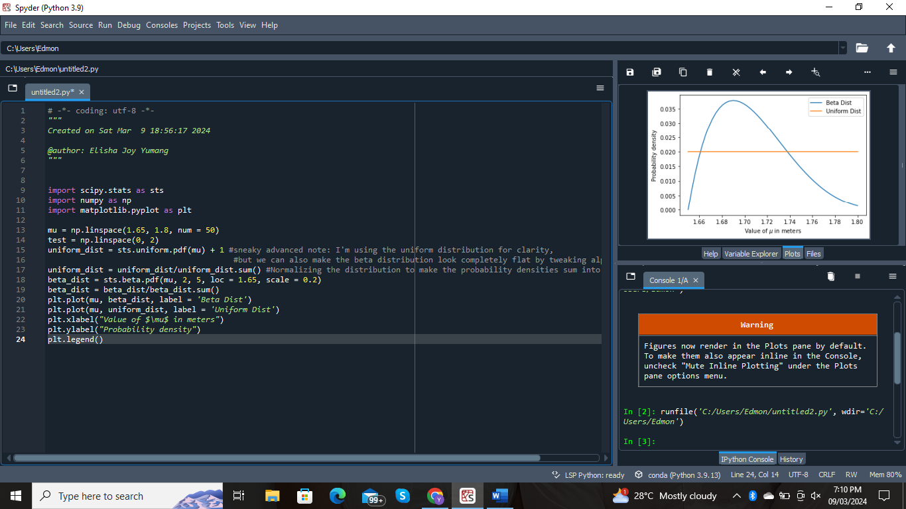1ST CODE

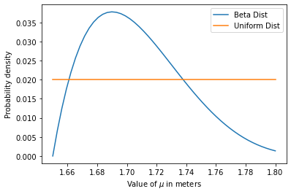

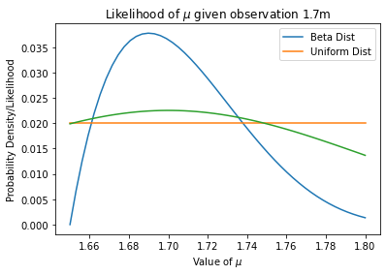2ND CODE

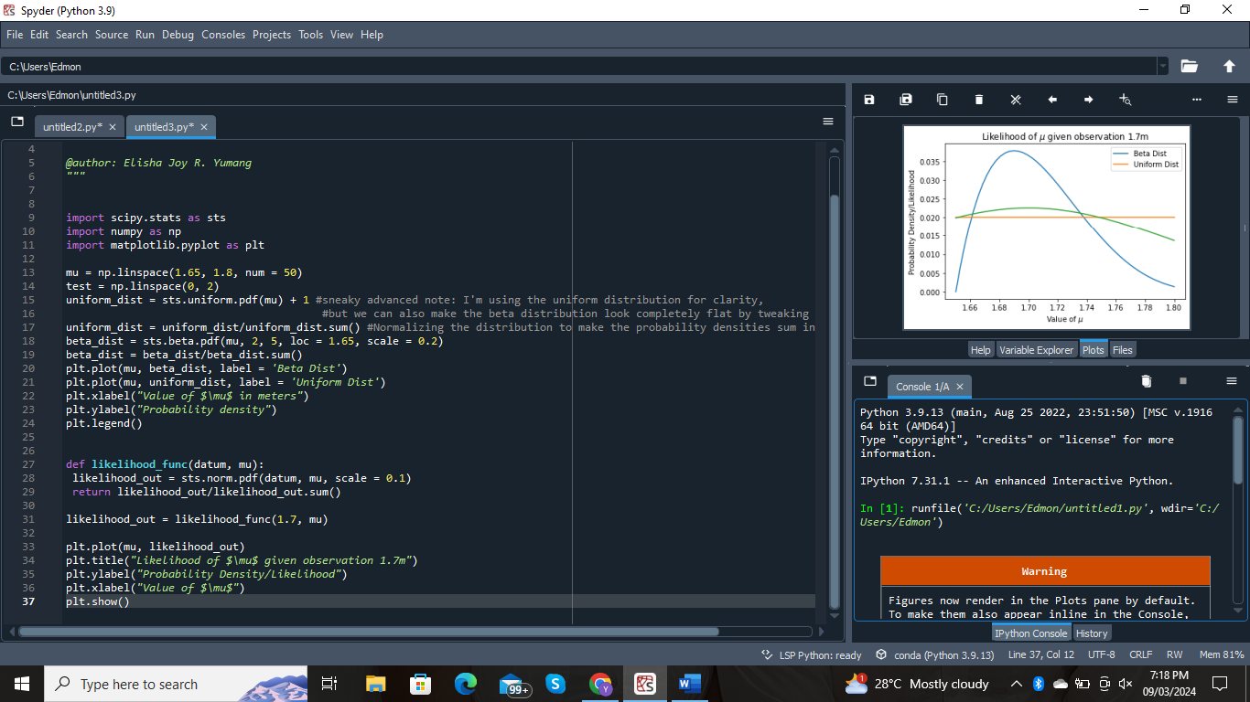

3rd CODE

